Document Title in English

*Author 1*

Institution, City, Country

e-mail

*Author 2*

Institution, City, Country

e-mail

**Abstract**. These instructions give you guidelines for preparing papers for CIET 2022*.* Use this document as a template if you are using Microsoft *Word*. Otherwise, use this document as an instruction set. Do not use special characters, symbols, or math in your title or abstract. The abstract should outline the main ideas and results of the paper. It should not exceed 400 words. Do not cite references in the abstract.

**Key words:** key words in English (max. 5)

# Introduction

The document should be set to A4 format (297x210 mm). The margins should be set to 30 mm top and 20 mm bottom and mirrored to 25 mm both outside and inside. The header should be set to 16 mm in height and the footer to 10 mm. Extra space between paragraphs, figures and tables should not be gained by inserting blank paragraphs. If in doubt, place and number the figures at the end of the paper and put captions at desired positions in the text.

# Paper formatting and styles

**The paper should be formatted using styles provided in this document and is limited to twelve pages, including figures and tables**. Each style is carefully prepared for corresponding purposes as shown in this document. Here are some guidelines:

* The whole document should be written in English (UK), 12 pt regular Arial, justified, spaced 3 pt before (*Body Text Indent* style for first line hanging 10 mm or *Body Text* style for text without hanging as authors find convenient).
* Document title: 16 pt bold (*Master_Heading_En* style).
* Authors: 11 pt italic (*Author* style).
* Chapter titles: 12 pt bold, numbered (*Heading 1* style).
* Subtitles: 12 pt regular, outline numbered (*Heading 2* style).
* Sub-subtitles: 12 pt regular, outline numbered (*Heading 3* style).
* Figure captions should be placed below figures, 10 pt regular (*Caption* style).
* Table captions should be placed above tables, 10 pt regular (*Table_caption* style).



**Figure 1** Single figure example

* Figures should be inserted “In line with text” (see Format object, Layout) if possible, containing a paragraph formatted using *Fig_body* style. Figures could be aligned to the left/right side with the text wrapping enabled if the author finds it necessary.
* Twin figures should be formatted using *twin_picture_body* style (with tabs).
* Twin figure captions should be formatted using *twin_pictures_caption* style (positioned with tabs).

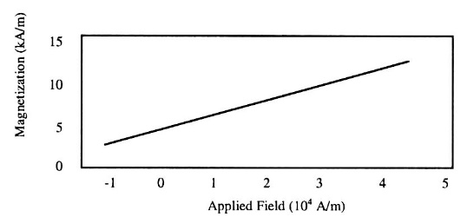 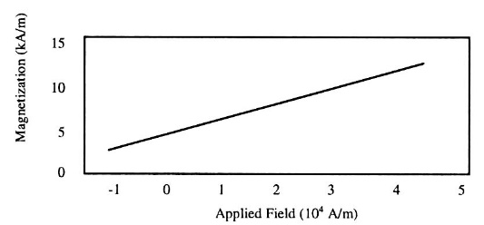

**Figure 2** First figure example **Figure 3** Second figure example

## Figures

Try to provide good quality figures, as you would wish them to look when published. Do not use embedded vector graphics because of possible side effects. Use raster graphics in a resolution not less than 300 dpi. Try to balance the figure size according to information you are trying to present to reader. Allow a small percentage of figure resizing for the sake of typesetting.

### Fonts

Please, do not use exotic fonts but those enclosed in the regular MS Windows installation. Missing fonts could have serious drawbacks in the final paper layout. In figures and equations, Times New Roman, Arial and Symbol can meet most of demands. If other fonts have to be used, please supply their names.

### Other recommendations

Use one space after periods and colons. Hyphenate complex modifiers: “zero-field-cooled magnetization.” Use a zero before decimal points: “0.25,” not “.25.” When expressing a range of values, write “7 to 9” or “7-9”. A parenthetical statement at the end of a sentence is punctuated outside of the closing parenthesis. Remember to check spelling and typing errors. Your paper could otherwise be returned for corrections.

## Tables

Tables should be left aligned or centred; inside grid thickness of ½ pt and border of 1 pt. The grid could be also omitted. Additional changes inside tables (merging cells, different thickness, etc.) can be made as authors find convenient. The text and numbers inside the tables should be formatted using *Body Text* style, aligned as needed.

**Table 1** Explanation of table content (*Table_caption style*)

|  |  |  |  |  |
| --- | --- | --- | --- | --- |
|  |  |  |  |  |
|  |  |  |  |  |

If the text follows a table, 12 pt space before should be applied.

## Equations

Equations should be written in MS Equation or similar math editor, compatible with MS Word, using the size settings as follows:

* Full 12pt,
* Subscript/Superscript 9pt,
* Sub-Subscript/Superscript 6pt,
* Symbol 18pt,
* Sub-Symbol 12pt.

Equations should be formatted using *equation_1* style with tabs, spaced before and after with 6pt in general, indented 20 mm from left (defined within the style).

 (1)

Equation numbers on the right side should be entered manually.

# References

References should relate **only** to the material you actually cited within your chapter (this is not a bibliography). References should be in **7th Edition** **APA citation style** and listed in alphabetical order. Exceptions are Technical Papers where citation numbers should be used and included in the text in square brackets (references are numbered sequentially in the text and in the reference list, with numbers repeated throughout the text as needed). Please do not include any abbreviations.

**Authored book:**

Author, A. A. (1994). *Title of work.* Publisher.

**Edited book:**

Zhao, F. (Ed.). (2006). *Maximize business profits through e-partnerships.* IRM Press.

**Chapter in an edited book:**

Jaques, P. A., & Viccari, R. M. (2006). Considering students’ emotions in computer-mediated learning environments. In Z. Ma (Ed.), *Web-based intelligent e-learning systems: Technologies and applications* (pp. 122-138). Information Science Publishing.

**Instance of publication in press:**

Junho, S. (in press). Roadmap for e-commerce standardization in Korea. *International Journal of IT Standards and Standardization Research.*

**Journal article:**

Sawyer, S., & Tapia, A. (2005). The sociotechnical nature of mobile computing work: Evidence from a study of policing in the United States. *International Journal of Technology and Human Interaction, 1*(3), 1-14.

**Unpublished doctoral dissertation or master’s theses:**

Wilfley, D. (1989). *Interpersonal analyses of bulimia: Normal-weight and obese [*Unpublished doctoral dissertation. University].

**Paper presented at … :**

Lanktree, C., & Briere, J. (1991, January). *Early data on the Trauma Symptom Checklist for Children (TSC-C).* Paper presented at the meeting of the American Professional Society on the Abuse of Children, San Diego, CA.

**Published proceedings:**

Deci, E. L., & Ryan, R. M. (1991). A motivational approach to self: Integration in personality. In R. Dienstbier (Ed.), *Nebraska Symposium on Motivation: Vol. 38. Perspectives on motivation* (pp. 237-288). University of Nebraska Press.

**Web site:**

Vanden Bos, G., Knapp, S., & Doe, J. (2001). Role of reference elements in the selection of resources by psychology undergraduates. *Journal of Bibliographic Research, 5,* 117-123. http://jbr.org/articles.html